
Pakistan Institute of Engineering & Applied Sciences
AICT_LAB PROJECT
Name | Registration# | Department | Program
Muhammad Sarfraz | 12-3-1-023-2025 | MME | Material Engineering
Mehwish bibi | 12-3-1-013-2025 | MME | Material Engineering
A console-based Laptop & Accessories Suggester

1. Introduction
In today’s fast-paced digital world, choosing the right laptop has become a challenging task due to the vast number of brands, models, and specifications available. Many users end up purchasing laptops that do not meet their actual requirements, resulting in wasted money and dissatisfaction.
Lapify is a console-based Python application designed to assist users in selecting suitable laptops and accessories based on their needs. The system provides laptop categories, brand listings, detailed specifications, accessories, FAQs, and company information through a simple menu-driven interface.

2. Problem Statement
Many customers follow market trends instead of understanding their personal requirements while buying laptops. This often leads to purchasing devices with unnecessary features or insufficient performance. There is a need for a simple, user-friendly system that helps users explore laptops and accessories logically and efficiently.

3. Objectives of the Project
The objectives of the Lapify project are:
- To guide users in selecting laptops according to categories
- To provide laptop brand and specification details
- To recommend accessories such as keyboards, microphones, and cooling pads
- To create an interactive menu-driven console application
- To use file handling (JSON) for structured data storage
- To minimize wrong purchasing decisions

4. Scope of the Project
The project is limited to:
- Console-based interaction
- Predefined laptop brands and categories
- Laptop data stored in JSON files
- Accessory recommendations
- Basic input validation
Future versions may include GUI support, live pricing, and online database integration.

5. Technologies Used
- Programming Language: Python
- Concepts Used:
  - Functions
  - Loops
  - Conditional statements
  - Exception handling
  - File handling
  - JSON data parsing
- User Interface: Console-based (Text UI)

6. Project Workflow
- Program displays a welcome screen
- Main menu is shown with available options
- User selects an option
- System performs the selected operation
- Program returns to main menu until exit option is chose

7. Main Menu Description
The main menu consists of the following options:
- View Laptop Brands
- View Laptop Categories
- Laptop Suggestor
- Accessories
- FAQs
- About Us
- Contact Us
- Exit Program

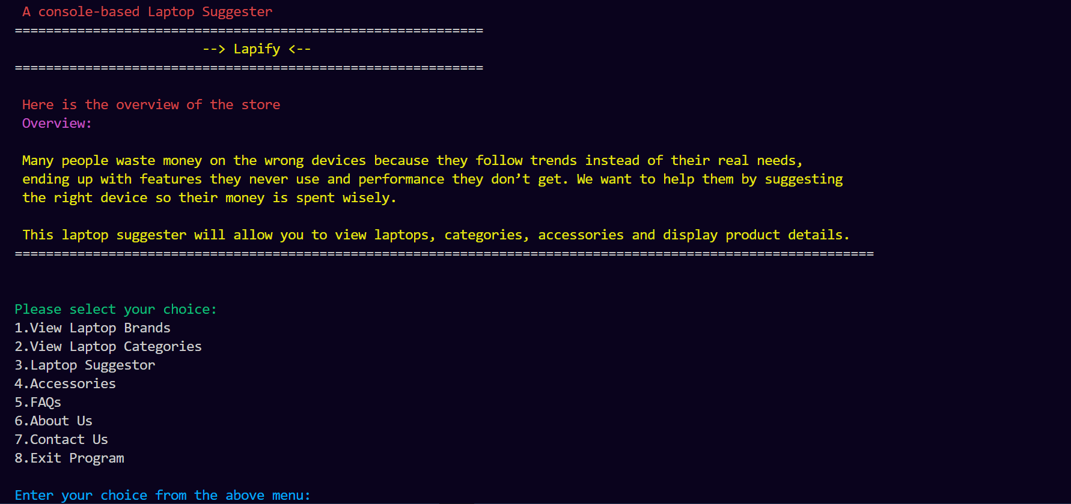

8. Module-Wise Description
8.1 Main Menu Module
Displays available options and navigates users to different features.
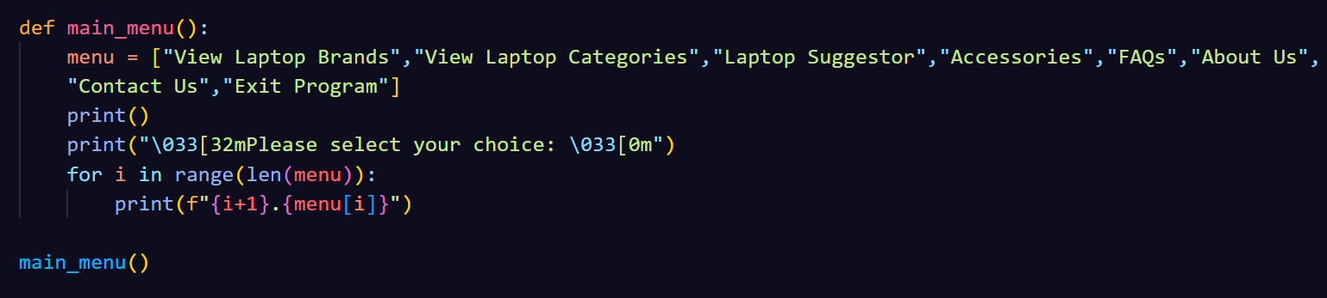
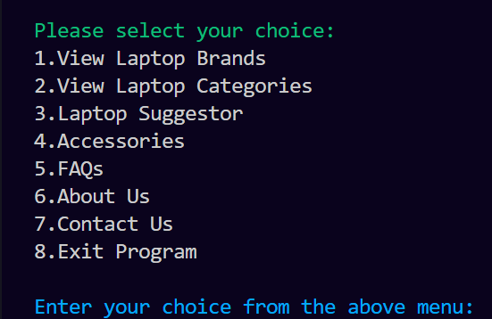

8.2 Laptop Brands Module
Displays a list of popular laptop brands such as Apple, HP, Dell, Lenovo, Asus, etc.
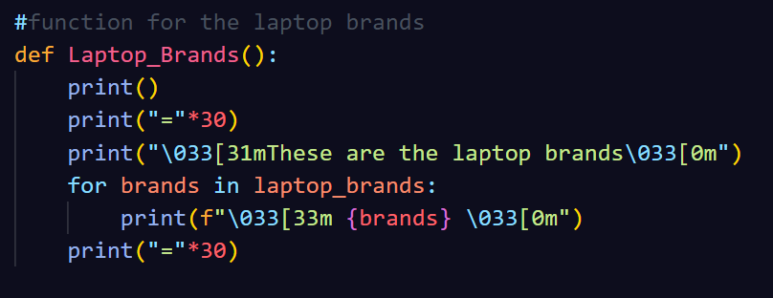
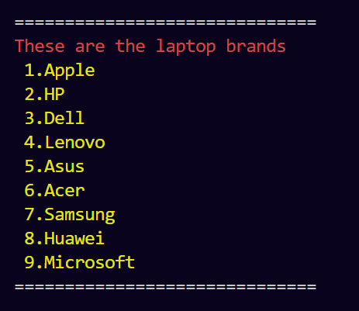

8.3 Laptop Categories Module
Shows laptop categories including:
- Business Laptops
- Gaming Laptops
- Workstation Laptops
- 2-in-1 / Convertible Laptops
- Budget / Entry-Level Laptops
Each category includes a brief description.
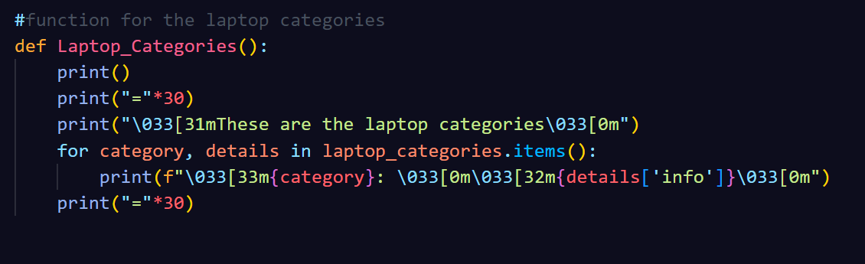
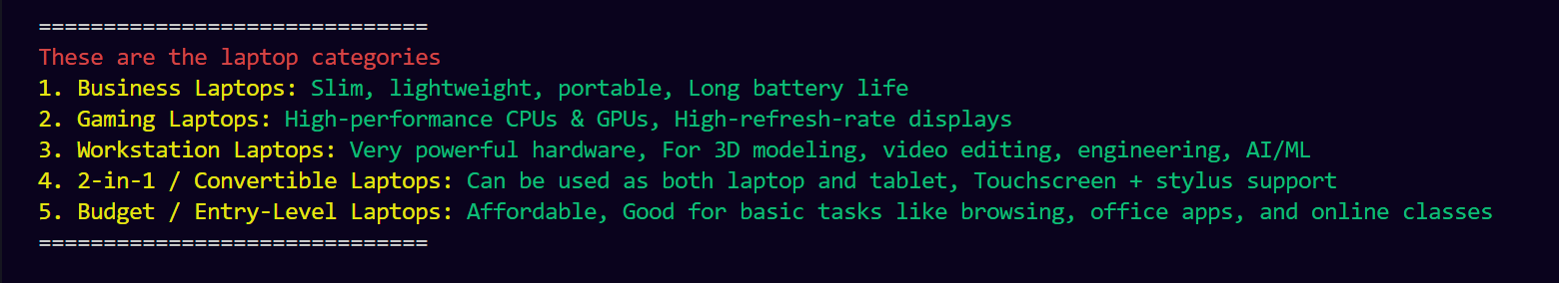
8.4 Laptop Suggestor Module
- Allows users to select a laptop category
- Displays companies and their laptop models
- Shows specifications such as processor, RAM, storage, and graphics
- Some specifications are restricted to paid access (simulation)
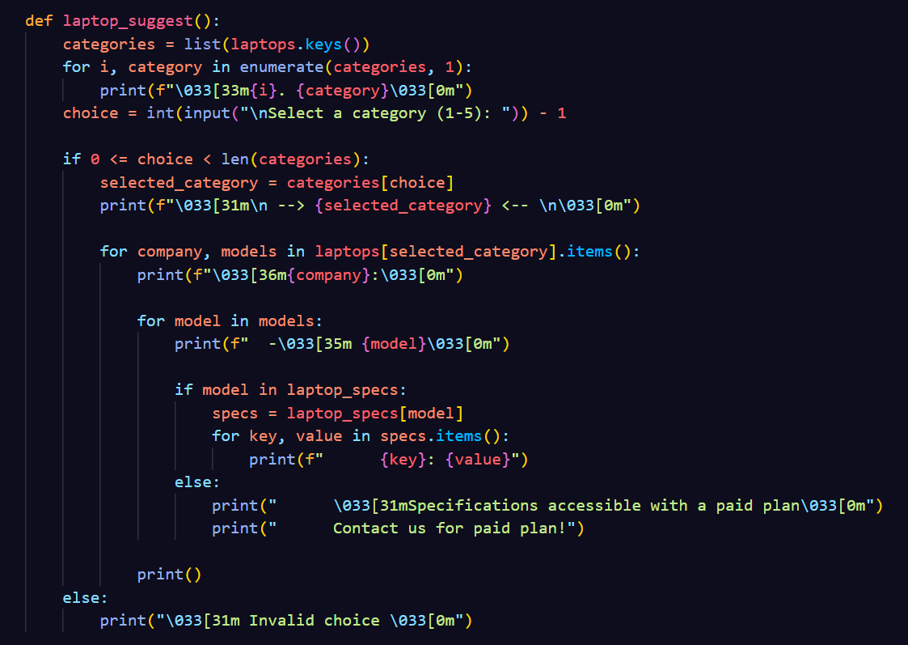

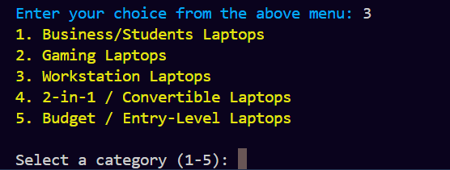

8.5 Accessories Module
- Reads data from laptop_accessories.json
- Allows users to choose:
  - Keyboard
  - Microphone
  - Cooling Pad
- Displays brand-wise accessory options
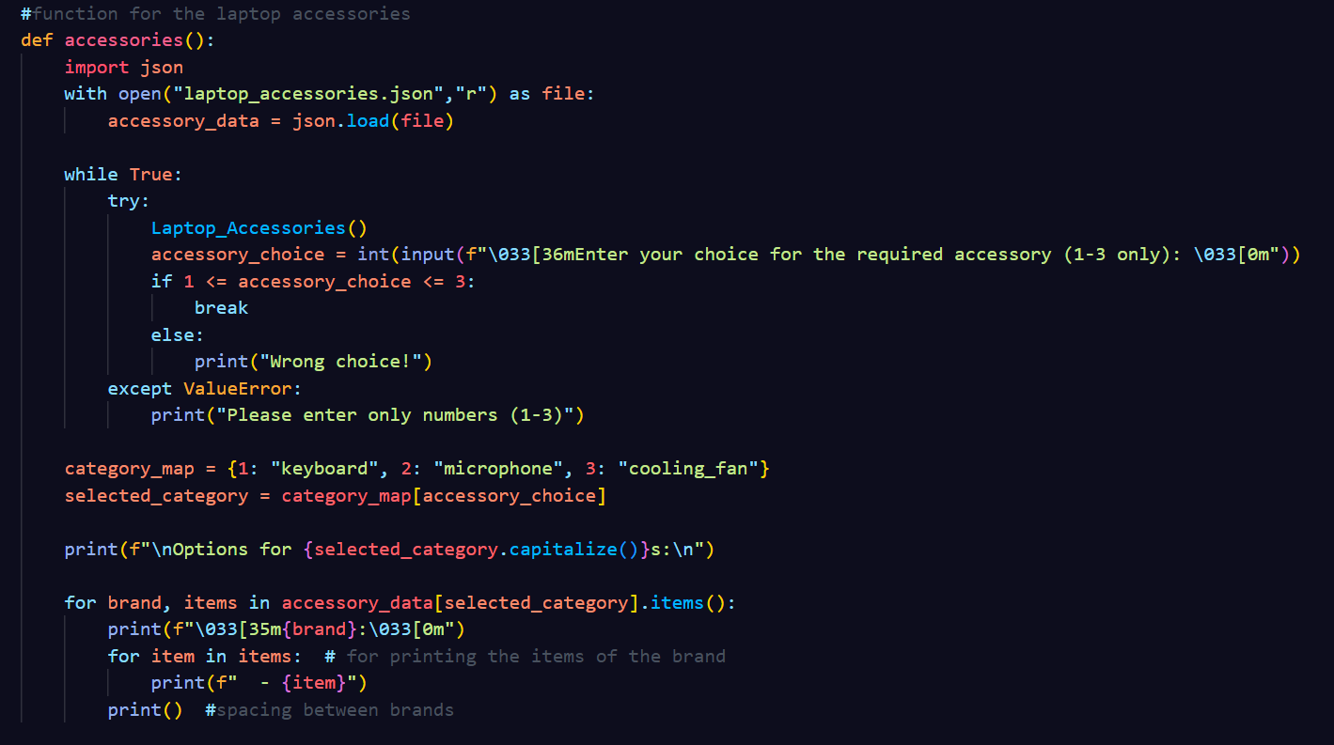

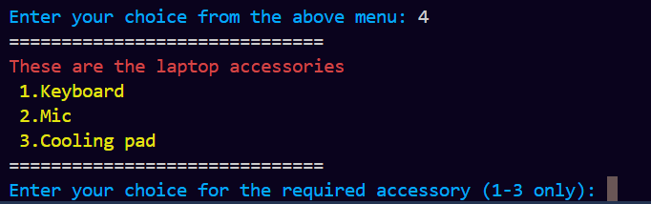
8.6 FAQs Module
Displays frequently asked questions and answers loaded from faq.json.

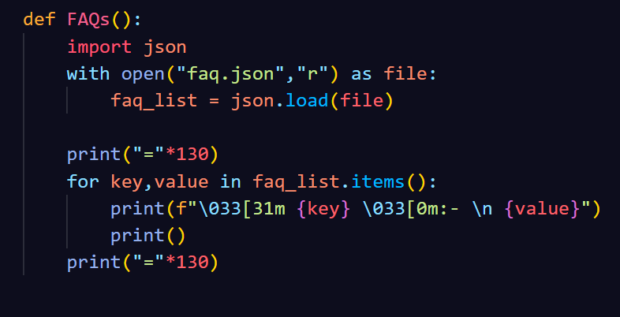
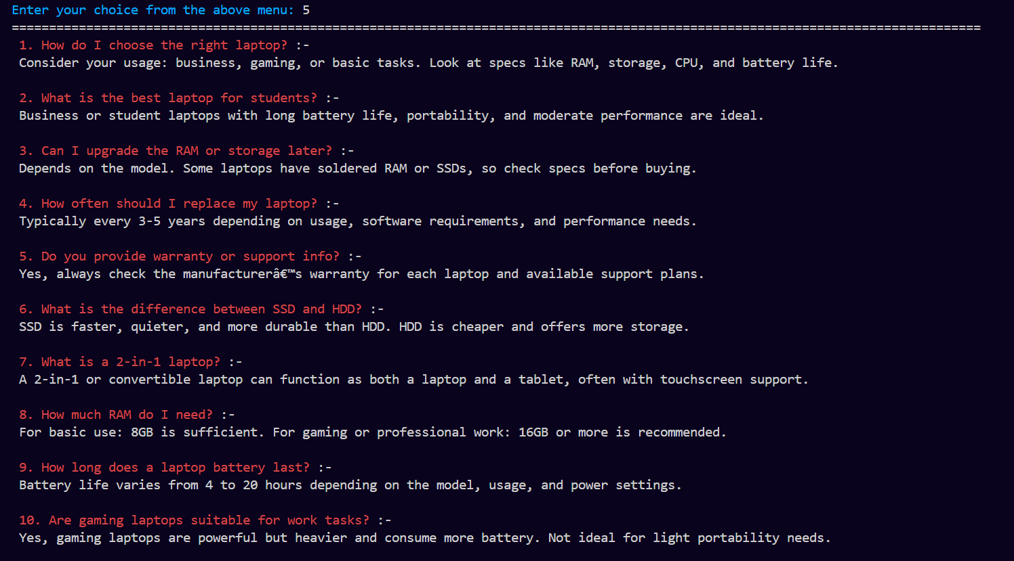

8.7 About Us Module
Describes the mission and goals of Lapify.

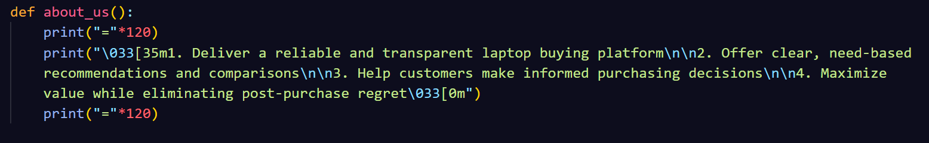
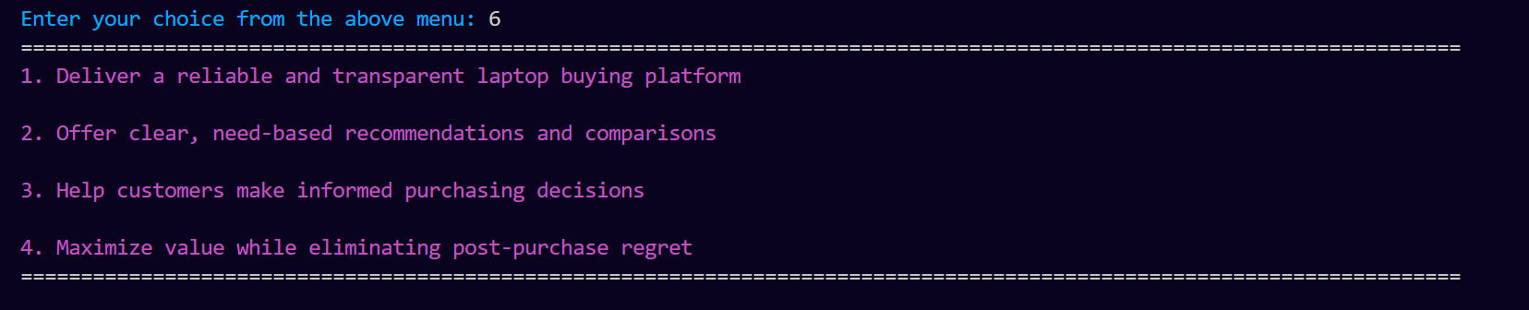

8.8 Contact Us Module
Displays company address, phone number, and email.
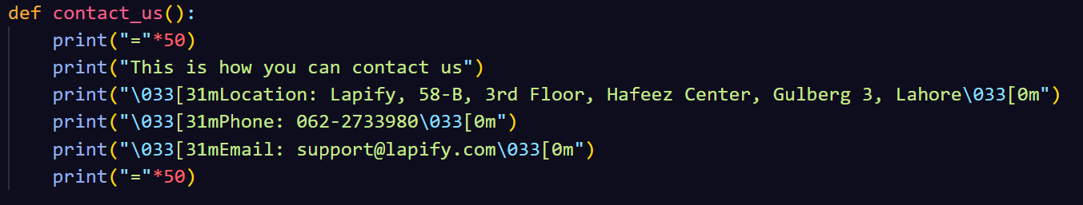
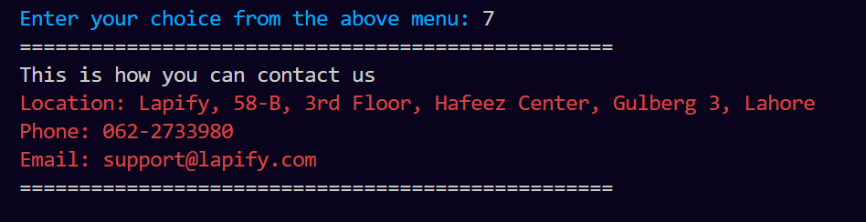

10. File Handling
The project uses JSON files for structured data storage:
- Laptop categories and models
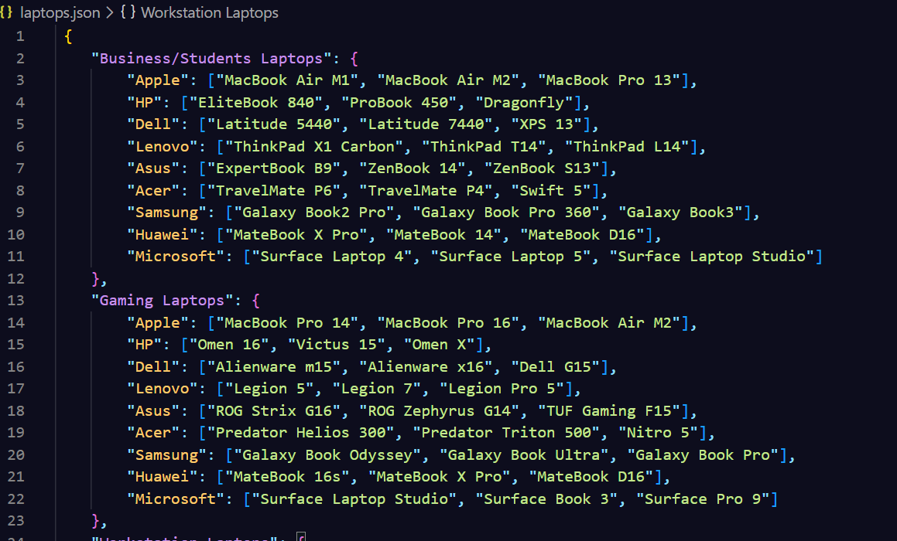

- Laptop specifications
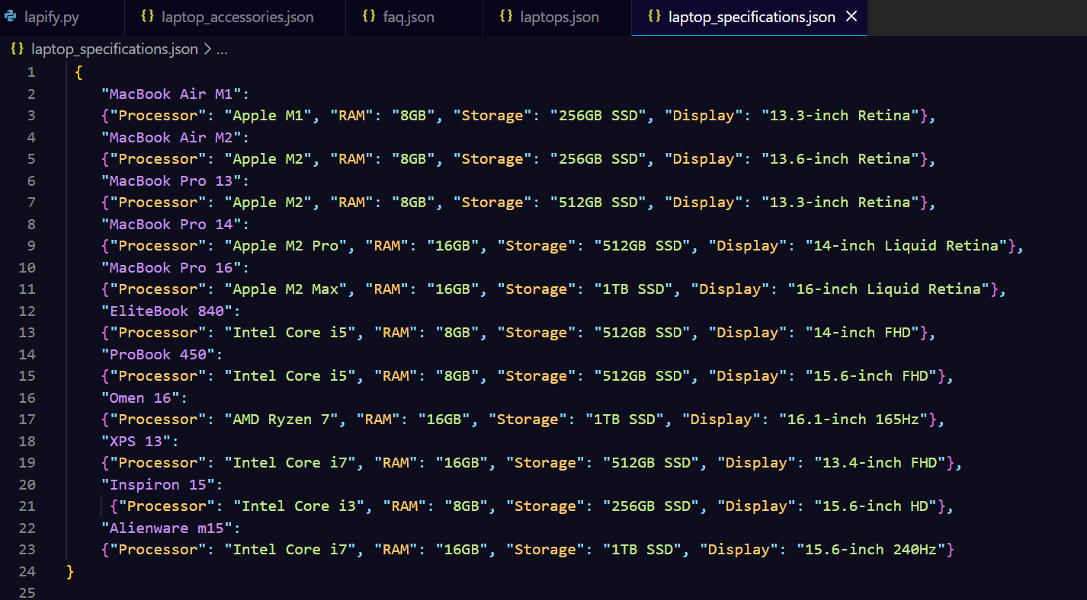
- Accessories
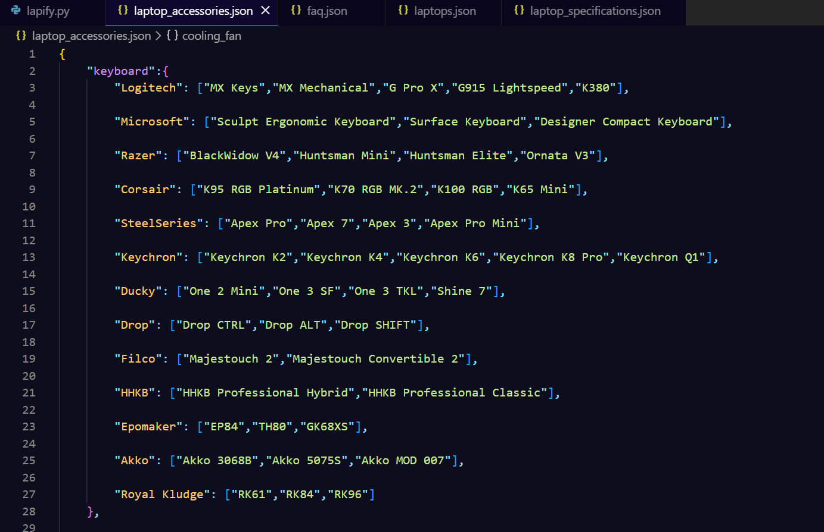
- FAQs
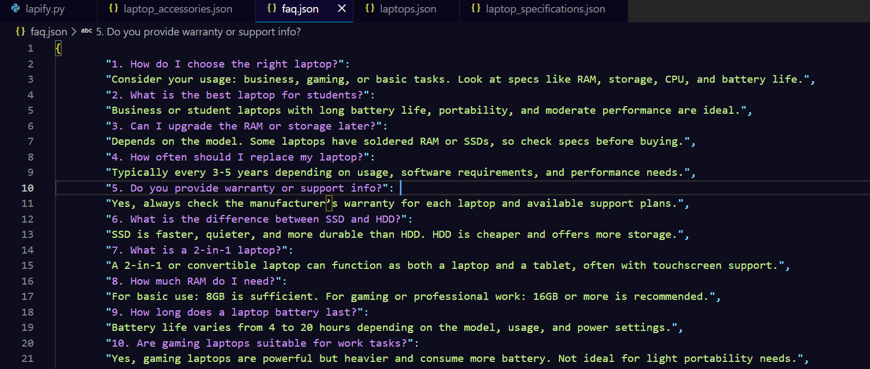
This approach improves scalability and data readability.

16. Conclusion
Lapify successfully demonstrates a console-based laptop and accessory recommendation system using Python. The project effectively applies core programming concepts such as file handling, modular design, and exception handling. It helps users make informed decisions while showcasing practical implementation of Python fundamentals.

